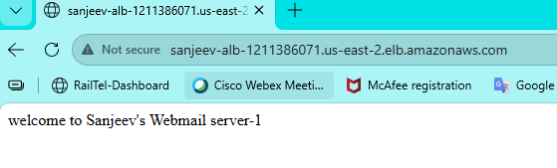
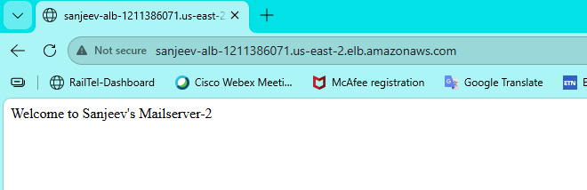
DNS Address: Sanjeev-ALB-1211386071.us-east-2.elb.amazonaws.com

